(Section 4 of 5)

What Students Will Learn to Do:
This chapter will introduce you to the Navy Junior Reserve Officers Training Corps—its background, mission, curriculum, and activities, as well as its benefits to cadets.

Skills and Knowledge to be Gained:
  - Explain the history and background of the NJROTC
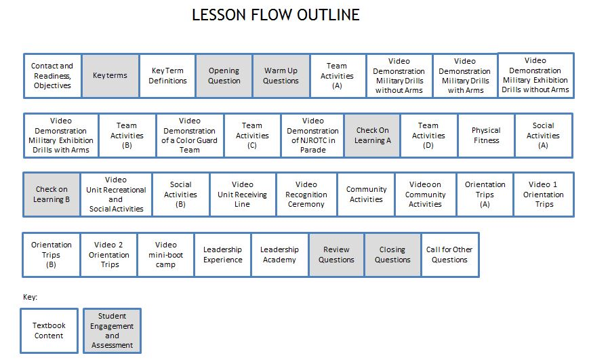
  - Describe the NJROTC’s mission, goals, and policies
Outline of Instruction:
- Preparation
            - Log in to TPC.
            - Expand the folders in the Content Window until you see NS1, U1, C1, S4.
Highlight the PPT - NS1-U1C1S4 – NJROTC Unit Activities
Click on PowerPoint Polling to open PPT and start slide show

            - Ensure that every student has a functional response pad and a textbook.

II. Instructional Flow:
Flow Item | Textbook Content / Student Engagement and Assessment | Slides
Establish contact and readiness; provide lesson overview and objectives review | Motivate students by relating real or imaginary events to help them see what the lesson will involve. Explain how this lesson ties in with other lessons.  In this lesson, students will learn about the NJROTC program. In addition they will:  1. Be able to state the program’s mission, goals, and policies.  2. Learn that the Navy Core Values- honor, courage, and commitment- are important parts of the NJROTC program, what they mean and how they are exemplified.  3. Learn what the Naval Science curriculum is all about  4. Learn the various activities in which NJROTC units participate.  5. Learn the benefits of belonging to the NJROTC | 1-3
Key term questions Slide index | Index Slide allows you to jump to any key term polling question. Clicking on the house icon at the bottom of any of the key term slides will bring you back to this index slide. | 4
Team Assignment (Hidden) | This is a hidden slide for gaming –It Is NOT required for the lesson | 5
Key terms - Questions | Ask students to respond to the questions covering each key term. | 6-7
Key terms - Definitions | Reinforce the correct definition for each key term. | 8
Opening Question-(Randomly Selected Student – “RSS”) | This Opening Question is “Where do you think an NJROTC Orientation trip might take you?” Since this is a discussion question, it can be engaged using the “Randomly Selected Student” icon on PPT slide to select a clicker number randomly. That student will orally answer the question (not with his/her clicker). You might allow the students to discuss the question for 30-60 seconds with a partner before engaging the RSS question. The MobiView tablet can be used to write the students’ responses to the question on the slide, focusing on NJROTC unit activities. | 9
Warm-Up Questions(Lesson questions 1-2) | Warm-up questions are typically used to gauge students’ level of interest, to generate interest in learning about upcoming topics, or to gauge prior opinions, knowledge or confidence in their knowledge, and/or uncover misconceptions that might be present. There may or may not be correct answers to these questions.  Ask students to respond to each Warm-up question, with follow-up discussion based on responses as appropriate. | 10-11
Team Activities | Explain that along with your fellow cadets, you’ll learn the basics of military drill, from simple in-place movements to the manual of arms (drill with a rifle). Most units also offer students the opportunity to participate in after-school drill activities like drill team and color guard. These teams will help develop your skills in military drill as well as provide a chance to join some of your fellow cadets in testing your skills against those of other JROTC units in drill competitions | 12
Video Demonstration of Military Drill Without Arms | Show video demonstration of Military Drill Without Arms | 13
Video Demonstration of Military Drill With Arms | Show video demonstration of Military Drill With Arms | 14
Video Demonstration of Military Exhibition Drill Without Arms | Show video demonstration of Military Exhibition Drill Without Arms | 15
Video Demonstration of Military Exhibition Drill With Arms | Show video demonstration of Military Exhibition Drill With Arms | 16
Team Activities | Explain that the role of a color guard team is more ceremonial than that of a drill team. The members represent the national colors and their services at events like football games or patriotic events by carrying our nation’s flag. Together drill teams and color guards represent their units both in competition and in the community, participating in school and community events as examples of our nation’s youth. | 17
Video Demonstration of a Color Guard Team | Show video demonstration of a Color Guard Team | 18
Team Activities | Explain that together drill teams and color guards represent their units both in competition and in the community, participating in school and community events as examples of our nation’s youth. | 19-20
Video Demonstration NJROTC in Parade | Show video demonstration of a NJROTC in Parade | 21
Video Demonstration of Color Guard | Show video demonstration of a Color Guard | 22
Check on Learning Questions A(Lesson questions 3-4) | Check in on student’s understanding of information covered so far by engaging lesson questions 3 and 4, with follow-up discussion as appropriate. | 23-24
Team Activities | Explain that Leadership Theory presents basic principles of leadership with special emphasis on ethics and morals involved with leadership. Case studies involving leadership decisions about right and wrong will be used to aid cadets’ understanding of the role of leaders. In Leadership Laboratory senior cadets are expected to plan, influence and direct the efforts of unit members in accomplishing the NJROTC mission. Cadets will have the opportunity to judge, evaluate and practice leadership skills they develop during NJROTC experience. | 25
Team Activities | Explain that in addition to drill, many units offer voluntary classes in range safety and marksmanship training, using precision air rifles. Cadets who excel in marksmanship often form teams to compete with nearby units, sometimes combining drill and marksmanship competitions into a single event. Unlike drill teams, marksmanship teams sometimes compete remotely. Such a competition is called a postal match. Each school team shoots, or completes its course of fire, at its own range and sends the targets to the competition sponsors for scoring. This makes it possible to hold national rifle competitions without spending time and money to travel to a central competition site.  Explain that in addition to these competitions, the Secretary of the Navy (SECNAV) sponsors an annual national rifle competition for all NJROTC units. | 26
Team Activities | Explain that the Naval Service Training Command sponsors another kind of annual national contest as well, an academic team competition. Each unit taking part fields a team composed of one to five cadets, all of whom take the same test locally on the same day. The NSTC then scores the results and declares the winners. These competitions can be combined with drill and rifle team meets to form a single grand event. | 27
Team Activities | Explain that another team opportunity provided to cadets is orienteering, which challenges cadets to use their land-navigation skills to go on a kind of large-scale treasure hunt. Those taking part must navigate cross-country over unfamiliar territory with a map and compass to locate control markers within a set amount of time. These competitions require speed, accuracy, good decision-making, and teamwork. The objective is to find as many markers as possible in the shortest time. | 28
Physical Fitness | Explain that NJROTC encourages students to be physically fit. All students take the NJROTC physical fitness exam. Those who pass are awarded the NJROTC physical fitness ribbon. Some receive a special ribbon in recognition of exceptional performance. | 29
Physical Fitness | Explain that throughout the year NJROTC units compete against one another in physical contests. These include individual activities—running, jumping, climbing, and running obstacle courses—as well as team games such as volleyball, basketball, softball, and tug of war. | 30-31
Social Activities | Explain that most NJROTC units have parties, picnics, and other social gatherings where cadets can hang up the garrison cap and enjoy the company of their fellow cadets. Some events are more formal than others, but no less enjoyable. Units may sponsor dining-ins, dining-outs, military balls, or honors and award ceremonies. The difference between the two kinds of dinner parties is that dining-ins are for unit members only, and a dining-out may include parents, friends, and other non-NJROTC participants.  Explain that dining-outs may be combined with award ceremonies where unit members receive ribbons, medals, and other awards at military formations in recognition of their contributions to their units and their communities. | 32
Check on Learning Questions B (Lesson questions 5-6) | Check in on student’s understanding of information covered so far by engaging lesson questions 5 and 6, with follow-up discussion as appropriate. | 33-34
Video on Unit Recreational and Social Activities | Show video on Unit Recreational and Social Activities | 35
Social Activities | Explain that a military ball is a formal dinner dance sometimes shared by multiple JROTC programs. Certain rules, procedures, and protocols govern an event such as a ball; for instance, the senior officer can set a dress code. | 36
Video on the Unit Receiving Line | Show video on the Unit Receiving Line | 37
Video on Unit Recognition Ceremony | Show video on Unit Recognition Ceremony | 38
Community Activities | Explain that NJROTC cadets can take part in a wide variety of community service work as part of their citizenship training. These events often provide the community with a much-needed service as well as an extremely rewarding experience for the cadets. | 39
Video on Community Activities | Show video on Community Activities | 40
Orientation Trips | Explain that orientation trips are one of the most important types of unit activities. Many units offer one or more of these, either during the school year or during school vacations. These trips, to military bases, ships, or air stations, bring to life the material cadets have been studying. | 41-42
Video 1 on Orientation Trips | Show first video on Orientation Trips | 43
Orientation Trips | Explain that these trips can be unforgettable experiences. Often cadets take part in or observe Navy training programs such as damage-control exercises, water survival or flight simulations. Some orientation trips include time training and living aboard a Navy ship. Such events let cadets experience firsthand what a Navy career really offers. Other orientation trips include an experience of basic military training such as Marine Corps boot camp or Navy recruit training. All these activities provide yet another opportunity for students to build and practice leadership skills as well as to meet members our Navy’s fighting force. | 44-45
Video 2 on Orientation Trips | Show second video on Orientation Trips | 46
Video on mini-boot camp | Show video on mini-boot camp | 47
Leadership Experience | Explain that no other school activity offers as many practical leadership opportunities as the NJROTC program. From the first time you serve as a squad leader in your unit until your senior experience as a unit officer, you’ll be challenged to lead and direct the efforts of others and to learn to accept responsibility for their successes and failures. | 48
Leadership Academy | Explain that some cadets get the opportunity for advanced training at NJROTC leadership academies. These academies are intended to help prepare these cadets for unit leadership roles.  Explain that leadership Academy has four objectives:  1. To promote habits of orderliness and precision and to develop respect for constituted authority.  2. To challenge and motivate cadets to push toward and expand their physical and intellectual limits. Cadets will continually be called upon to meet high standards of personal appearance, self-discipline, and meticulous attention to detail.  3. To instill a high degree of personal honor, self-reliance, and confidence in each cadet by presenting a military environment in which cadets will be forced to rely upon themselves and their shipmates to study, work, and learn.  4. To enhance the basic attitude, knowledge, and skills required to practice the art of leadership. | 49
Leadership Academy | Explain that the Leadership Academy offers cadets the opportunity to improve their leadership skills and interact with other promising cadet leaders from units across the nation. | 50
Review Question-  (Randomly Selected Student – “RSS”) | The Review Question is “What are some of the types of team competition in which your NJROTC unit might compete?” Question is designed to provide an opportunity for some reflection and assimilation of the content covered, and is to be engaged with the Randomly Selected Student Icon as the Opening Question above. MobiView can be used here to write the students’ best responses for visual reinforcement, and to foster discussion. | 51
Closing Questions (Lesson Questions 7 - 8) | Have students respond to questions 7 and 8 covering the final segment of the lesson, with follow-up reinforcement and discussion as appropriate. | 52-53
Call for Other Questions | Provide the opportunity for students to ask final questions regarding the content covered. | 54

III. Supplemental Activities -
A. In class Activity:
Supplies required: Handout
When: could be used during or at the end of class
- Have the cadets use the handout to rate the NJROTC Activities and circle their response.
- Use the guide below as a gauge:
1 - Not really interested • 5 - Would like to try • 10 - Already like.

B. Homework Activity: Have the Cadets go to youtube.com and search NJROTC. List at least 5 different activities that they are interested, rate them in order of interest and give reasons why they are interested.

IV. Evaluation - see TPC Content Window (U1C1-Assessments folder) for chapter test questions.

Activity 1 – In class Activity –
Name: _______________________________ Date: ___________ Class: ___________

Directions: Rate these NJROTC Activities as to like and dislike. Use the guide below and circle your response:
1- Not really interested • 5 - Would like to try • 10 - Already Enjoy

Armed Drill  UnArmed Drill  Color Guard  Marksmanship  Academics  Physical Fitness  Orienteering  Fitness Competitions  Social Activities  Recreational Activities  Basic Leadership Training  Leadership Academy  Community Service | 1 2 3 4 5 6 7 8 9 10  1 2 3 4 5 6 7 8 9 10  1 2 3 4 5 6 7 8 9 10  1 2 3 4 5 6 7 8 9 10  1 2 3 4 5 6 7 8 9 10  1 2 3 4 5 6 7 8 9 10  1 2 3 4 5 6 7 8 9 10  1 2 3 4 5 6 7 8 9 10  1 2 3 4 5 6 7 8 9 10  1 2 3 4 5 6 7 8 9 10  1 2 3 4 5 6 7 8 9 10  1 2 3 4 5 6 7 8 9 10  1 2 3 4 5 6 7 8 9 10

Activity 1: Take Home Activity –

Name: _______________________________ Date: ___________ Class: ___________

Directions: Go to youtube.com and search NJROTC. List at least 5 different activities that interested you and rate in order of interest. Give reasons why you found each one interesting.

- ___________________________________________________________________________

- ____________________________________________________________________________

- ____________________________________________________________________________

- ____________________________________________________________________________

- ____________________________________________________________________________

